**Product Description:**

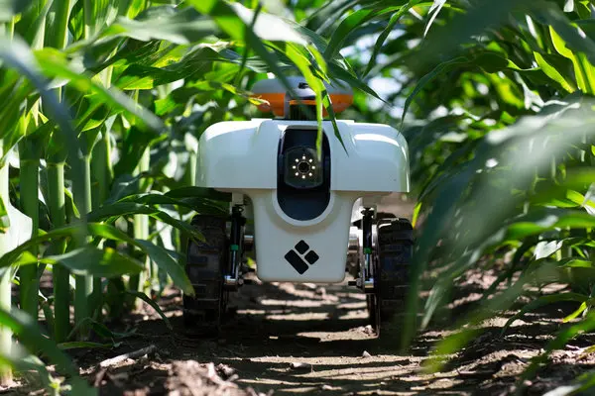

Our robots can be used in various ways to test agricultural soil. Robot is programmed to navigate through fields and collect soil samples at specific locations. there are some sensors in our product to determine the factors. Those are:

* Location Sensors
* Optical Sensors
* Electro-chemical sensors
* Mechanical Sensors
* Acoustic and Pneumatic Sensors
* Inertial sensors

A display will also be there to see the updates of the soil and a camera to control the area.

**Background:** Agriculture is the largest employment sector in Bangladesh. Bangladesh produces a variety of agricultural products such as rice, wheat, corn, fruits, vegetables etc. Rice is the main staple in the Bangladeshi diet. In this business proposal we are introducing a robot which will help to detect the soil for the better harvesting. An agricultural robot is a robot, deployed for agricultural purposes. The main area of application of robots in agriculture today is at the harvesting stage.

**Services**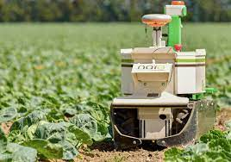

Collecting the sample form the field and determine various soil parameters such as pH level, nutrient levels, moisture, temperature, and other environmental factors.so they can apply fertilizers, pesticides, and herbicides more efficiently. This approach can help reduce waste of the crop and also improve crop quality. Overall, using robots in agricultural soil testing can help farmers to improve productivity and better quality of product

Agritech bd

**Market opportunities**

Soil detection robotics in agriculture presents a significant market opportunity as it offers a range of benefits to farmers and the agricultural industry. Soil detection robotics can play a critical role in precision agriculture by providing farmers real-time information about soil properties, like, moisture, pH, and nutrient levels. This information can be used to optimize the use of fertilizers, water, and other resources, leading to higher crop yields, reduced waste, and lower costs. According to a report by Research and Markets, the global agricultural robots’ market is expected to grow from $4.1 billion in 2020 to $10.5 billion by 2025, representing a CAGR of 20.6%. Soil detection robotics is expected to be a key driver of this growth. The demand for precision agriculture, sustainability, and cost reduction robotics is expected to increase, creating opportunities for businesses to develop innovative solutions to meet the needs of farmers and the agricultural industry.

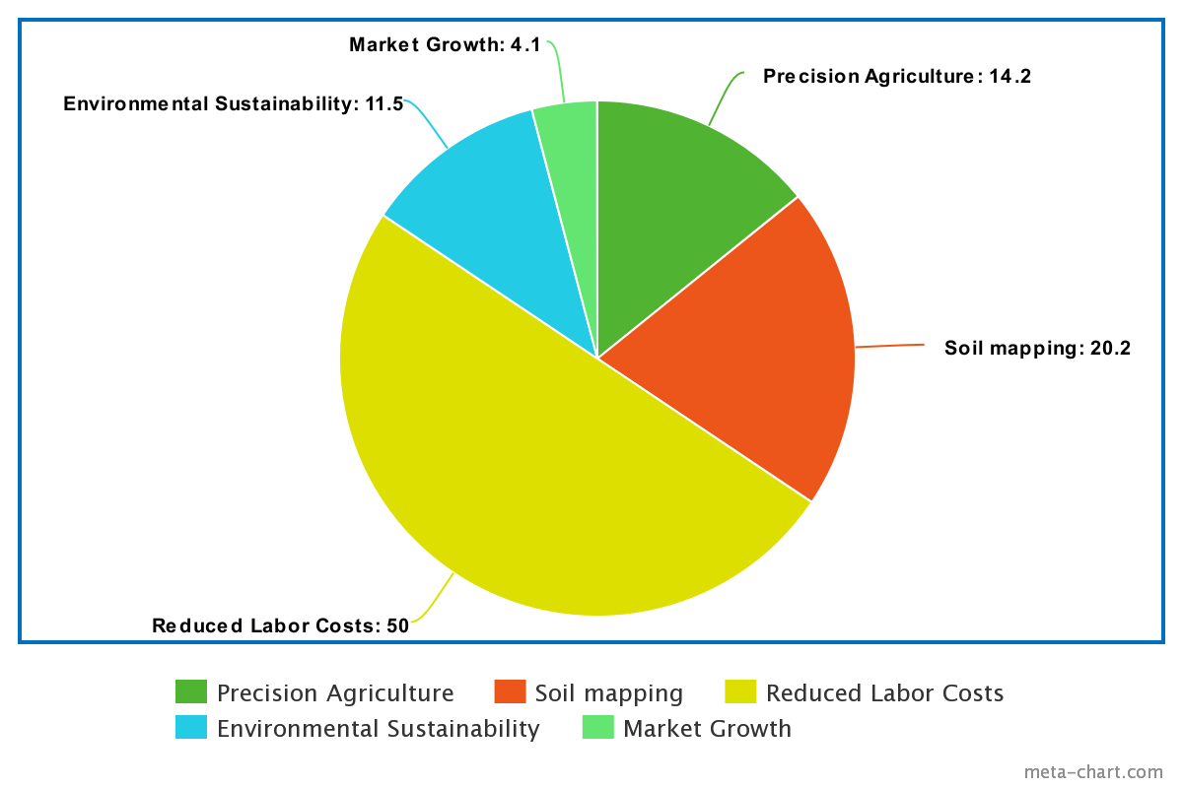

**About Us:**

We Engineers are often creative problem-solvers and have a unique ability to identify and address complex challenges. By becoming an entrepreneur, we can use our skills and expertise to develop innovative solutions that can disrupt existing industries and create new ones. As an entrepreneur, we can set our own goals, make our own decisions, and chart our own course. Entrepreneurship can offer financial independence and the potential for significant financial rewards as well. Of course, entrepreneurship is not for everyone, and there However, we are very optimistic to take on the challenge, it can be a rewarding and fulfilling path to pursue.

**A Robot to detect Soil condition**

**Board of Directors: Hriday Sarkar, Arpita Acharjee, Mehedi Hasan**